Определите, тип, вид, хора, изложение:

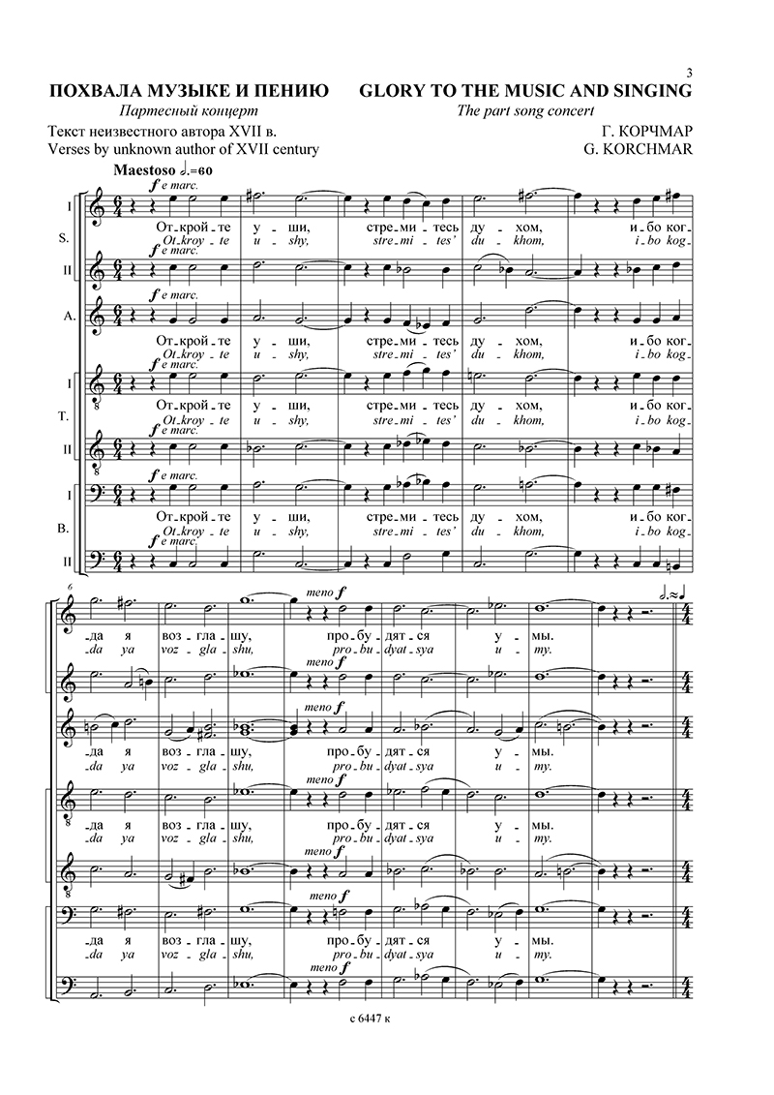

___________________________________________________________________________________-

2.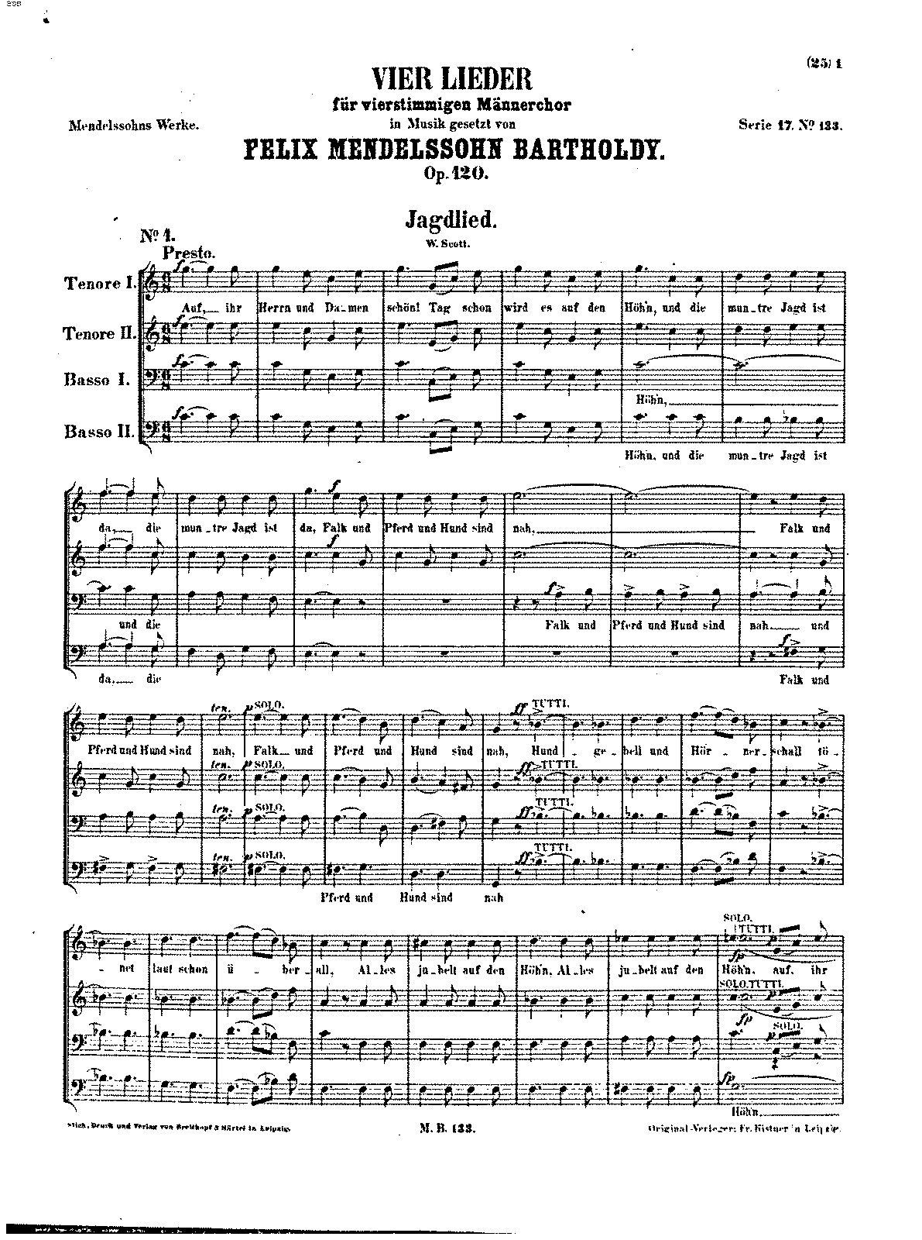

3.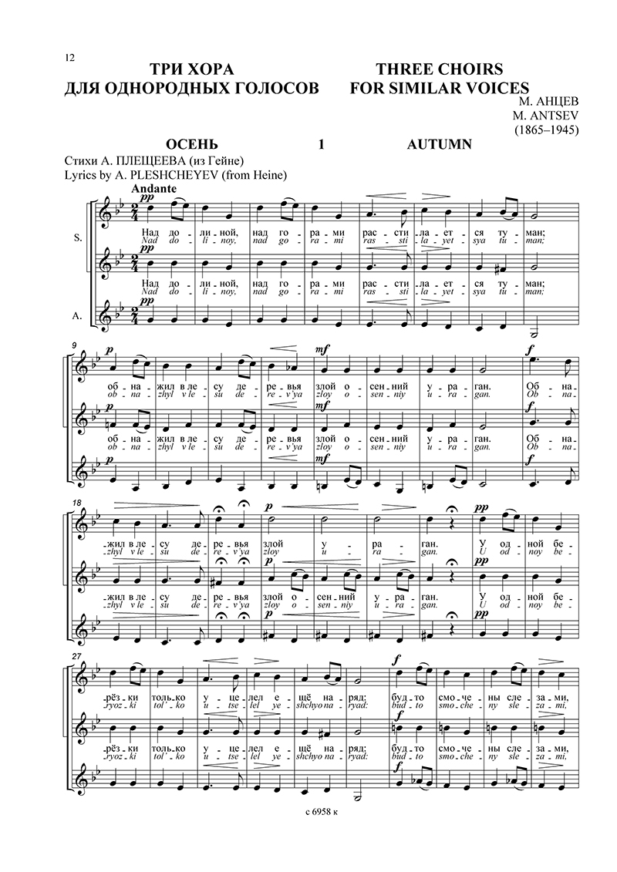

__________________________________________________________________________

4. 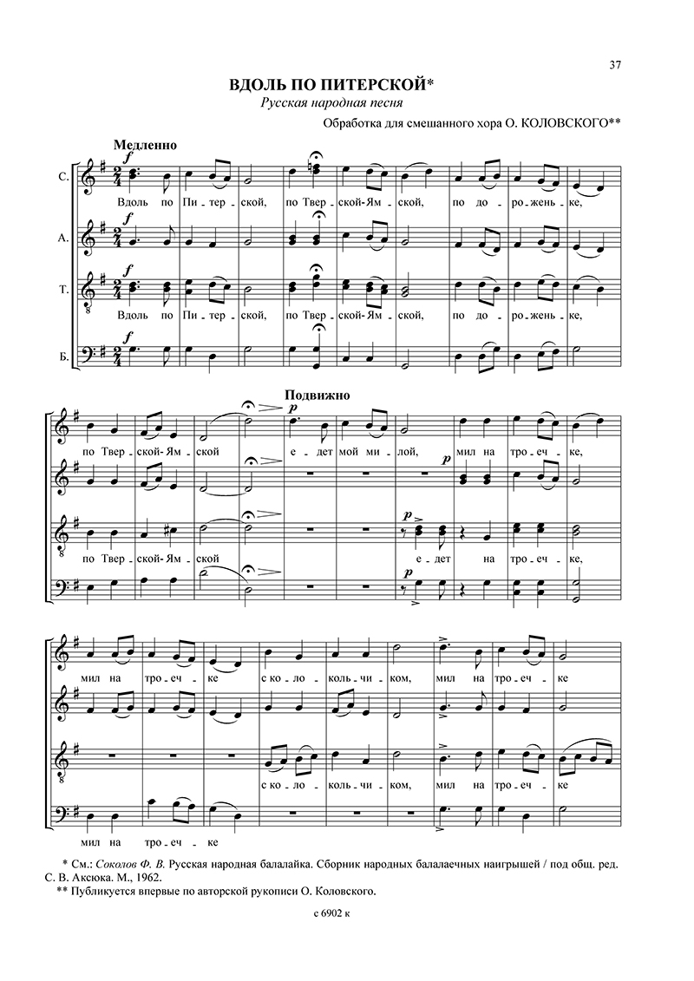

5. 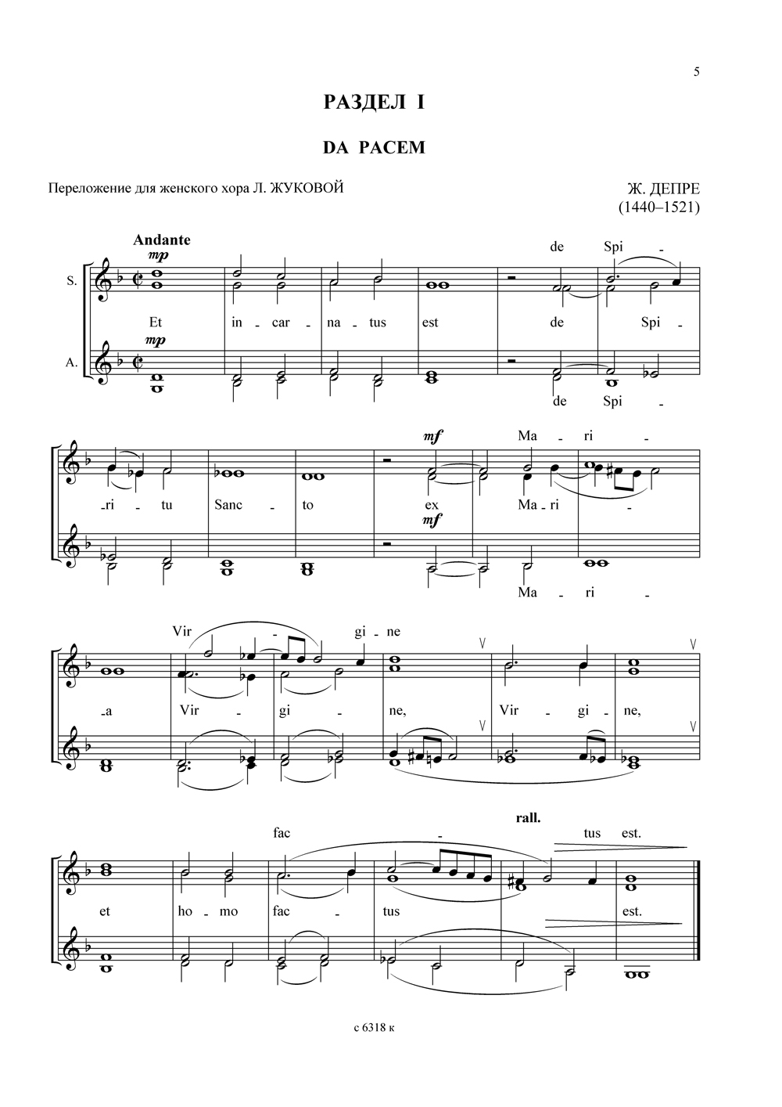

6.

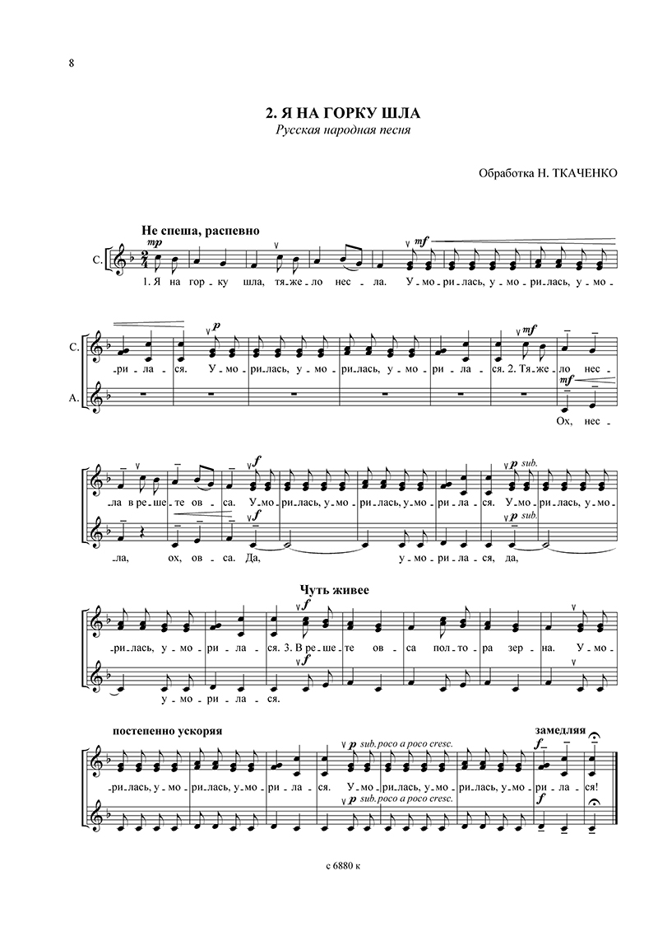

7.

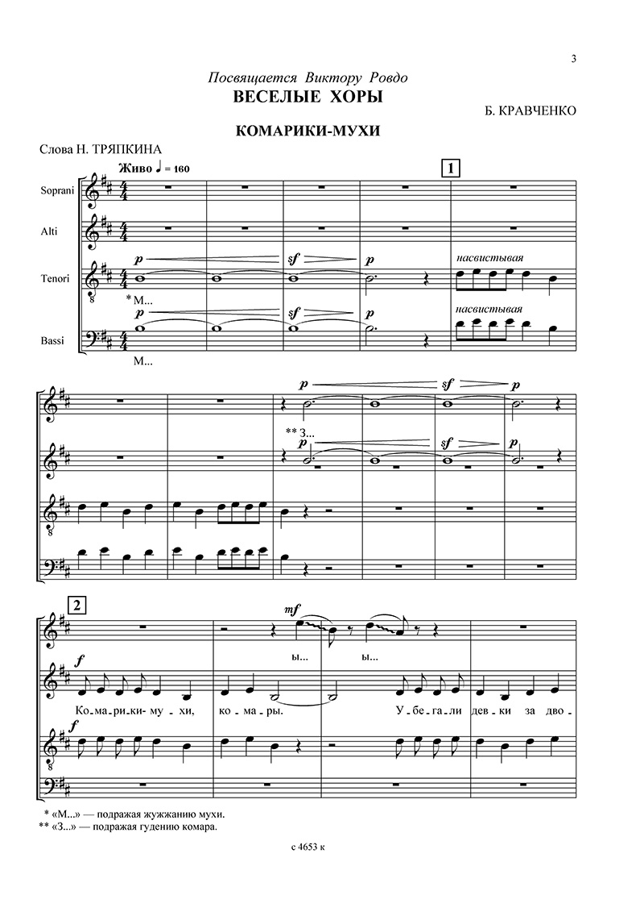

8. 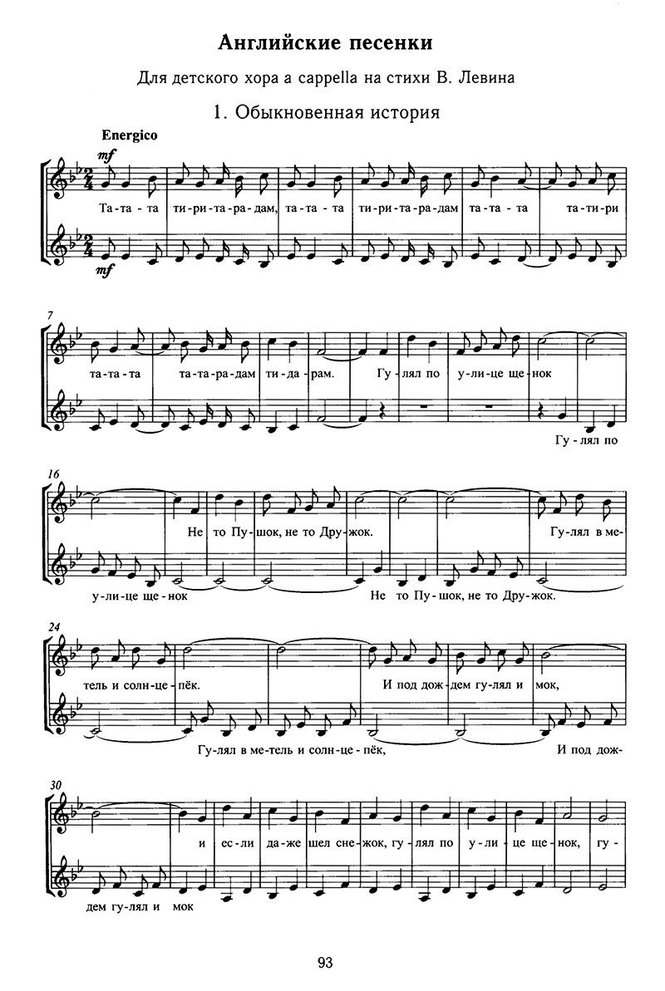

9. 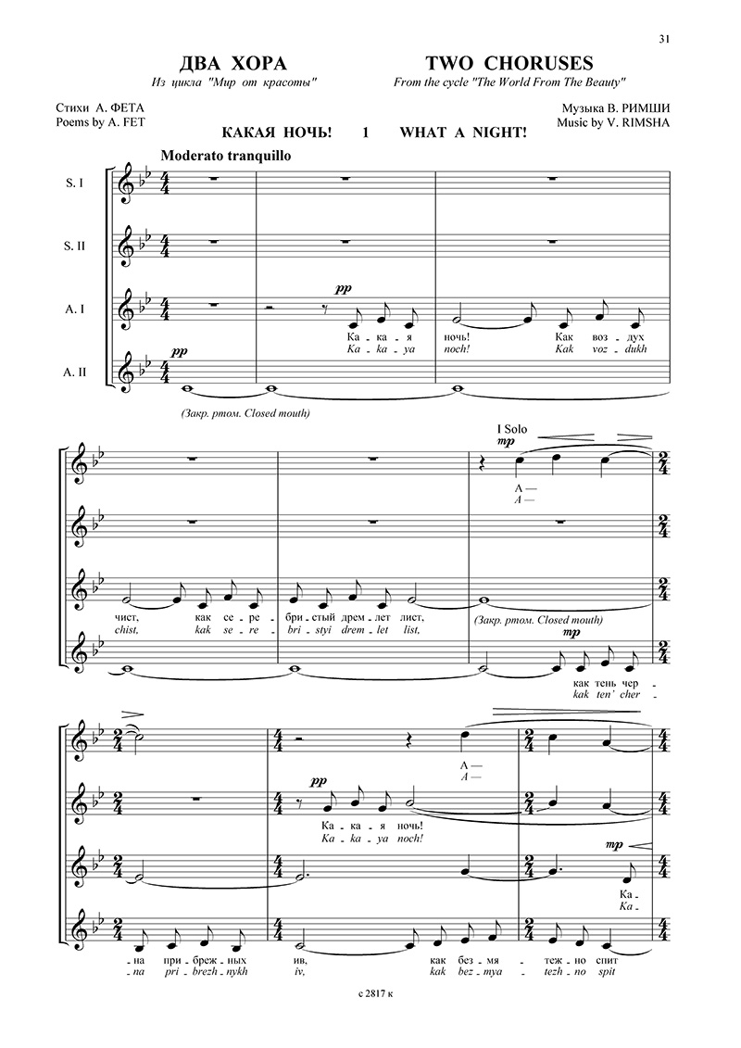

10. 

